UTILITY EXTENSION POLICIES
Who Pays?

By Reem Abdelrazek
MTAS MPA Intern

TABLE OF CONTENTS
Introduction……………………………………………………………………………………….3

Regional Examples………………………………………………………………………………...4

Crossville, Tennessee……………………………………………………………………....4
Cookeville, Tennessee……………………………………………………………………..4
Nashville, Tennessee…………………………………................................................................4
Mooresville, North Carolina……………………………………………………………….5
Jacksonville, Florida………………………………………………………………………..5
Gatlinburg, Tennessee……………………………………………………………………..6
Memphis, Tennessee…………………………………………………………………….....6
Cleveland, Tennessee……………………………………………………………………....7
Lufkin, Texas……………………………………………………………………………....8
Alcoa, Tennessee…………………………………………………………………………..8
Tennessee Association of Utility Districts………………………………………………….8

Conclusion………………………………………………………………………………………..10

INTRODUCTION

As cities continue to grow and annex land, utility extension issues are certain to arise. Cities do not want to bear the financial burden of new development or have the entailed costs fall on their current residents.

In most cities, developers bear the entire cost of utility extensions and relinquish ownership of mains to the municipality. There may be a partial reimbursement, but the developer is usually wholly responsible for costs incurred. However, some municipal officials suggest cities should strike a balance between costs and incentive for developers; an entrepreneurial spirit to promote development that will yield positive return on investments.

The purpose of this article is to present differing municipal practices of utility extension procedure and funding strictly for undeveloped land within city limits. Examples below are taken from municipal charters and policy and the Tennessee Association of Utility Districts Subdivisions and Developers regulations.

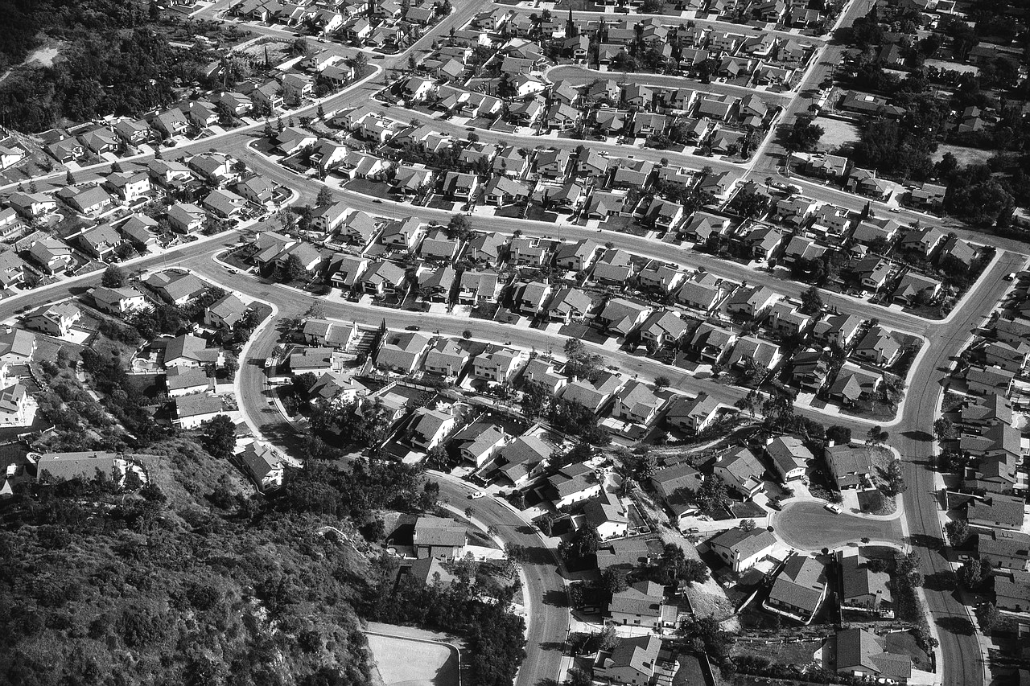
REGIONAL EXAMPLES
The following are municipal code excerpts and explanation from ten cities in and near Tennessee on utility extension policies. Please note, any italicized text or text in bold font has been made so by the author for the purpose of emphasis.

CROSSVILLE, Tennessee

Crossville’s municipal code states, “The requirements and procedures for main extensions for land development projects and subdivision promotions are to be set forth in a separate section” (§18-109). The Subdivision Regulations for Crossville Planning Region is a very detailed booklet, explaining the procedures, provisions, design specifications, etc. It implies that all costs are the responsibility of the developer. The only relief granted developers comes in the following statement:

When the Planning Commission finds that a developer will encounter extraordinary hardships or practical difficulties resulting from strict compliance with these regulations and/or the purposes of the regulations may be served to a greater extent by an alternative proposal, the Planning Commission may approve variances to these Subdivision Regulations so that substantial justice may be done and the public interest is secured.

COOKEVILLE, Tennessee

§18-109

“Water main extensions inside the city limits not requiring planning commission approval, shall be limited to 100 feet at the expense of the department, with the balance of the extension at the expense of the applicant.”

“All connections to existing mains shall be made by the department with the developer or customer either furnishing or paying the total cost of all material used.”

NASHVILLE, Tennessee

All proposed residential developments within the Department’s (of Metro Water Services) water or sewer service areas require a determination of the availability of sewer and/or water services (application + $50.00 fee).

Based on a sewer capacity study, the customer must pay capacity fees, currently assessed at $500 per unit of flow (350 gpd per single family dwelling). A minimum of 30% of the sewer capacity fees due must be paid within 60 days of the date of the letter sent to the customer to reserve sewer capacity. The 30% will reserve capacity for one year from the date of the availability letter.

After availability has been ascertained, developers must submit plans and an engineering design report. The developer must retain the services of a State of Tennessee Professional Engineer to prepare construction plans. A licensed utility contractor is required to perform all proposed public utility extension work. Contractors shall construct all water and/or sewer facilities according to MWS specifications, in conformance with applicable Metropolitan Code.

The financial responsibility falls on the developer.

MOORESVILLE, North Carolina

§ 2.02

“Upon receipt of a petition to extend a water and/or sewer main, the Town Board has the following six options for response:

- Install the extension at the Town’s expense.
- Approve and allow the petitioner to install the extension at his expense.
- Install the extension at the petitioner’s expense.
- Install and jointly finance the extension in cooperation with the petitioner.
- Jointly finance and install the extension in cooperation with the County in accordance with the intergovernmental agreement.
- Deny the request.”

“The Town Board may also extend water and/or sanitary sewer mains on their own volition without receipt of a petition and assess the cost or collect utility fees…from those who connect to the main.”

JACKSONVILLE, Florida

Jacksonville has a Water and Sewer Expansion Authority (WSEA) to “provide property owners with an opportunity to finance water and/or sewer infrastructure…on a voluntary basis. In new neighborhoods, developers install the infrastructure as the homes are built and pass those costs on to the new homebuyers.” Then, the Jacksonville Electric Authority (JEA) takes over maintenance of those lines.

Capital costs can be financed by the homeowner over a number of years. However, a project must have at least 50% participation within the neighborhood to be considered cost feasible. New customers will receive monthly bills for regular water/sewer charges, as well as a capital charge to pay for the infrastructure over a 20-30 year period. Only those in the neighborhood who want the services will be charged the monthly service and capital charges. The city will contribute 30% of the total costs for the first 500 residential customers. The agreement allows for monthly payments over a period of up to 30 years with a low interest rate.

Owners also have the option to participate in the cost of the project but to not connect when the system is available; this allows owners to begin paying for the main infrastructure but delay connection costs. A lump sum payment will be required for a later connection to the system for those owners who do not participate in the beginning of the project in addition to the on-site costs of connection. Additionally, those who do not participate initially will lose the opportunity to finance and the 30% cost participation originally contributed by the WSEA.

GATLINBURG, Tennessee

§18-106

“Service lines will be laid by the municipality from the water main to the property line at the expense of the applicant for service.

“Before a new service will be laid by the municipality, the applicant shall pay a tap fee…”

“The tap fee does not include the cost of service assembly, i.e., connecting to main water line and furnishing and installing service line, meter, meter box, yoke, fittings, pavement repair, or other restoration work, all of which is to be borne by the customer requesting the service.”

§18-108

Customers desiring main extensions to undeveloped areas must pay all of the cost of making such extensions. The water mains shall become the property of the department.

“As a further consideration, the department shall, for a period of five years (and no longer), repay to the person or persons who pay the cost of such a water main extension in the amount of the then existing tap fee charge for each new service line connection attached to said extension within a five-year period. The total payments for new service connections shall in no event exceed the cost of said extension to the person or persons who paid therefore.”

MEMPHIS, Tennessee

§12.1.1

New main extensions to existing mains will be made with the size mains deemed necessary to maintain no less than a Class II fire rating by the ISO. The customer will be required to finance only that size main necessary to serve his demands but in no event less than a six-inch main where fire protection is required.

§12.1.2

Necessary water main extensions and residential connections will be made without cost to prospective residential customers who occupy existing structures at the time of annexation

§ 12.2.1

If a customer or developer financing of water main extensions is required, the necessary funding will be made by a payment in cash, non-refundable, of an amount equal to 100% of the estimated cost of the distribution system as shown on the approved plan.

§12.2.2

The customer or developer has the option to install mains by a private contractor. If this option is selected, the customer or developer must install the mains in accordance with Memphis Gas Light & Water’s (MGLW) plans, specifications, and contract. This option requires the customer to pay MLGW’s estimated cost for engineering and administration. Additionally, the customer will pay an inspection fee of $500 + 1% of the total estimated cost.

§12.3.2

MLGW will prepare a sketch detailing the proposed water system. If the developer requires MLGW to redesign any system or deviate from a standard design, the developer may be required to pay a redesign fee in addition to the cost of the new design.

§12.5

The developer must install sewers and drainage facilities.

CLEVELAND, Tennessee

“Any new development inside the corporate limits of the city will only be allowed for approval if it includes extension of water ands sanitary sewer lines to the property line. No new development will be considered by the city if the plans include the use of septic tanks for sewage disposal. The developer will be responsible for all costs associated with the planning, engineering, easements, plans review, inspection and construction of the water and/or sewer extension within the development, including service connections to the property line.”

All service lines, mains, pumps, etc. will become a part of the City of Cleveland’s water and/or sewer system and all ownership will transfer to the City. However, “the developer will be responsible for all maintenance and repairs of the mains, service lines, pumps, etc., installed inside the development, for a period of 12 months (one year) from the date of connection to the city system.” After the 12 months, the city will bear full responsibility for maintenance and repairs.

All property owners or households will pay an access fee and pay for water and/or sewer services based on the rate schedule as set forth by the City of Cleveland.

“Those households and/or property owners whose property is contiguous (adjacent to the property line) to the main extensions necessary to serve new developments will be required to connect to the water and/or sewer mains.” Contiguous property owners must also pay an access fee, for water and/or sewer services, and shall agree to pay a portion of the line extension costs (through a special assessment based on a front footage charge of the abutting property). If the tap is installed by a private contractor, an inspection fee is also required.

Should the city desire larger mains within the development than that required for the development, the city agrees to pay the cost difference for installing the larger main.

LUFKIN, Texas

Within the city limits: If the extension of service to a property is inside the city limits of Lufkin, the city will extend utility service to the nearest property line that is the most advantageous to the city. The extension of service will be at no cost to the owner or the developer. Any upgrades in infrastructure will be completed by the city at no cost.

Outside city limits, the cost of the extension of utility service will be borne solely by the developer. In the event of future connections to the utility service by other subdivisions or developers, the original developer “will be reimbursed a prorated share based on a per unit cost for a period up to five years. The cost shall be determined based on the point of connection of the new development. After five years no cost will be reimbursed to the Developer.”

ALCOA, Tennessee

§18-503

“Developers of new subdivisions or developers installing water lines within new subdivisions for the purpose of developing property for sale shall bear the full cost of the design and construction of the lines. When the city desires a main larger than that required for the development the city will reimburse the applicant for the difference between the two. The city may also participate in main extensions when warranted by high volume consumption, favorable return on investment, or overall economic impact on the community. Testing and sterilization of mains upon completion shall be furnished by the developer.”

Tennessee Association of Utility Districts

Guidelines and Regulations:

“The city will require that developers who seek to profit from residential or commercial construction pay their fair share of such costs. Should the costs of construction be unusual or other unusual circumstances exist, the city may modify or add to these procedures.”

“The costs and expenses incidental to the installation, connection, and inspection of city wastewater service facilities for residential subdivisions and commercial developments shall be borne by the DEVELOPER. In addition, the DEVELOPER shall indemnify the city from any loss or damage … for a period of one year after city’s acceptance of the facilities.

“The DEVELOPER or his assignee will be responsible for obtaining all easements.”
All plans must be approved by city engineer.

“The DEVELOPER shall obtain all permits (building, plumbing, electrical, etc.) … and shall comply with the requirements of all other governmental agencies having jurisdiction.

“The DEVELOPER will pay the city for plans and review fees related to water and wastewater plans. … The city will send the plans and review fee to the Tennessee Department of Environment and Conservation for approval.

“The DEVELOPER gives the city a bond or letter of credit for 100% of the construction costs of proposed improvements as estimated by the city or the city’s engineer. … The city, in writing, may waive the bond for contracts under $25,000.

“Prior to the execution of a contract for over $25,000, the city shall require the DEVELOPER to post a bond with corporate surety authorized to do business in the State of Tennessee or obtain an irrevocable letter of credit issued by a national bank or a bank authorized to do business in the State of Tennessee for the costs…

“Prior to the execution of the contract, the DEVELOPER must pay all fees and charges currently established by the city for the DEVELOPER which may include but are not limited to the following: All Tap Fees; Connection Fees; Storage Fees; A Security Deposit or Non-Refundable Service Charge; and Plan Review Fees.

“The DEVELOPER will be permitted to connect to the city’s existing lines provided the lines extended to and throughout the development shall become the property of the city free and clear of the claims of any persons or entities, except as provided otherwise herein.”

Although these codes and policies are exhaustive, cities should and do allow for flexibility.
CONCLUSION

Some municipalities have variance clauses that provide relief from strict adherence to extension policies. For example, the municipal code for the town of Jasper, Tennessee states, “Whenever the governing body is of the opinion that it is to the best interest of the municipality…to construct a water and/or sewer main extension without requiring strict compliance with the preceding section, such extension may be constructed upon such terms…approved by the governing body” (§18-110). The city of Mooresville, NC seems to have the best policy, in that it gives the governing body six options when approaching utility extensions.

Cities also have consideration for property outside city limits. As in the case Lufkin, Texas, the city “will extend utility service to the property for the first 200 feet at no cost to the owner.” The owner is then responsible for anything beyond the first 200 feet. Conversely, some cities will not even consider services for property outside city or growth boundary limits.

Another tool cities use to attract developers is reimbursement plans. For instance, Gatlinburg will, for a five year period, repay those who paid for a water main extension for each new service line connection to said main. This practice or a similar variation is available within several municipalities, as a means to offset high costs for the property owners and/or developers.

One Tennessee city manager suggested cities should encourage developers by paying 20-25% of the total cost of extensions when there is a predicted positive return of investment. He promoted cooperation and negotiation to encourage developers while also opening the doors of revenue for cities. However, one technical consultant argued that developers will make more than enough through plot and home sales that it is not too much at all to require them to pay the cost of extensions.

Ultimately, it seems the most practical and beneficial policy to handle utility extensions is providing the governing body with flexibility and options.

