Smoke Detector placement and installation
The placement of smoke detectors is very important. Sleeping areas need the most protection. One detector in a short hallway outside the bedroom area is usually adequate. Hallways longer than 30 feet should have one detector every 30 feet. A smoke detector should be installed in every room that will be occupied.
Be sure to keep the detector away from fireplaces and wood stoves to avoid false alarms. Place smoke detectors at the top of each stairwell and at the end of each long hallway. Smoke rises easily through stairwells. If you should put a smoke detector in your kitchen, be sure to keep it away from cooking fumes or smoking areas.
Proper mounting of a smoke detector also is important. You can mount many detectors by yourself, but those connected to your household wiring should have their own separate circuit and be installed by a professional electrician. If you mount your detector on the ceiling, be sure to keep it at least 18 inches away from dead air space near corners. If you mount it on the wall, place it four to 12 inches below the ceiling and away from corners. Keep them high because smoke rises.
Never place them any closer than three feet from an air register that might re-circulate smoke. Don't place them near doorways or windows where drafts could impair the detector operation. Don't place them on an uninsulated exterior wall or ceiling. Temperature extremes can affect the batteries.
Installation:
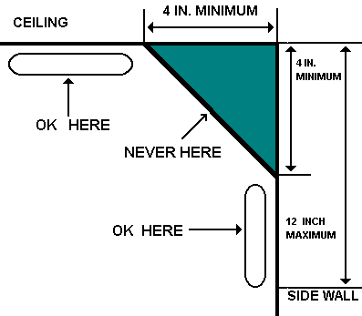

- Do not place a detector closer than 3 feet from an air register that might re-circulate smoke.
- Make sure smoke detectors are at least 18 inches from a corner.
- Do not place a unit on an uninsulated exterior wall or ceiling.
- Place smoke detectors at least 3 feet from ceiling fans.
There are two basic types of smoke detectors:
- Ionization detectors - Ionization detectors contain radioactive material that ionizes the air, making an electrical path. When smoke enters, the smoke molecules attach themselves to the ions. The change in electric current flow triggers the alarm. The radioactive material is called americium. It's a radioactive metallic element produced by bombardment of plutonium with high-energy neutrons. The amount is very small and not harmful.
- Photoelectric detectors - This type of detectors contain a light source (usually a bulb) and a photocell, which is activated by light. Light from the bulb reflects off the smoke particles and is directed towards the photocell. The photocell then is activated to trigger the alarm.
Keeping smoke detectors in good condition is easy. Always follow the manufacturer's instructions. Be sure to replace the batteries every year or as needed. Most models will make a chirping, popping or beeping sound when the battery is losing its charge. When this sound is heard, install a fresh battery, preferably an alkaline type.

