Warning!
Sanitary Sewer Overflow!
No swimming, fishing, or physical contact!
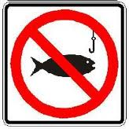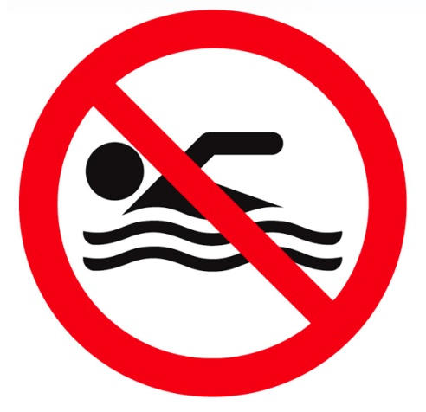

For more information or to report additional problems call:
City of XXXXX
WWW-ZZZ-YYYY

