This example manual was developed along with other tools to assist cities with developing and documenting internal control practices.
City of Everywhere Internal Control Manual
June 30, 2016
MTAS Finance and Accounting Team

Table of Contents
2 Introduction 1
3 Considerations in Development of Internal Controls 3
3.1 The Green Book states documentation is management’s responsibility: 3
4 Five Components of Internal Control 4
4.1 Control Environment 4
4.1.1 Sample Organizational Charts for Various Municipal Structures 7
4.1.1.1 Strong Mayor 7
4.1.1.2 Weak Mayor 8
4.1.1.3 Council Manager 9
4.1.1.4 City Administrator 10
4.1.1.5 Commission Form 11
4.1.1.6 Departmental Structures 12
4.2 Risk Assessment 17
4.3 Control Activities 19
4.3.1 General Collections/ACHs 19
4.3.1.1 City Courts 22
4.3.1.2 Property Tax Collections 23
4.3.1.3 Utility Billings and Collections 23
4.3.2 General Disbursements/Drafts 23
4.3.2.1 Payroll disbursements and payroll liabilities 25
4.3.3 Safeguarding of Assets 26
4.3.4 Compliance 27
4.4 Information and Communication 28
4.5 Monitoring 30
4.6 Summary 32

Internal Control Manual

Introduction
The City of Everywhere has the responsibility to its taxpayers, ratepayers and constituents to be good stewards of public monies and property. In our efforts to serve the public as city officials or employees, the City established this Internal Control Manual using widely recognized best practices and state and federal directives.
State of Tennessee statutes require the Comptroller’s Office, Department of Audit to prescribe uniform accounting systems for entities that handle public funds. Those statutes require public officials to adopt and use the system designated by the Comptroller’s Office. The Tennessee Legislature amended TCA Section 9-2-102 in 2015 to require local governments to establish and maintain internal controls in accordance with guidance issued by the U.S. Government Accountability Office (GAO). The guidance is titled Standards for Internal Control in the Federal Government (Green Book). The Green Book follows the format developed by the Committee of Sponsoring Organizations (COSO) which has been the gold standard of internal control for all entities except the federal government for several years.
The internal control system consists of three objectives and 5 main components. Within the 5 components there are 17 principles that apply to certain components. The state considers the 5 elements mandatory and the 17 principles are optional. The City of Everywhere has chosen to only address the minimum requirements of the state in this manual however the 17 principles from the Green Book are presented below for informational purposes and to help explain the 5 components.
Three (3) objectives of internal controls:
1. Reporting – reliability
2. Operations – effective and efficient
3. Compliance – compliant with applicable laws, regulations, contracts and grant agreements
Five (5) main components of internal controls that are required to be addressed:
1. Control Environment
2. Risk Assessment
3. Control Activities
4. Information and Communication
5. Monitoring

The purpose of this manual is to ensure that the objectives of reporting and compliance are established. (The operational objective will be addressed at a later time.) The policies to achieve the objectives are derived from various financial best practices, state and federal laws, and regulations and policies may be developed to suit specific needs of city functions and resources. Detailed procedures are then developed and documented as a means for cities to comply with its established policies.
OV2.09 The Green Book

Figure 3: The Five Components and 17 Principles of Internal Control:

Control Environment:
- The oversight body and management should demonstrate a commitment to integrity and ethical values.
- The oversight body should oversee the entity's internal control system.
- Management should establish an organizational structure, assign responsibility, and delegate authority to achieve the entity's objectives.
- Management should demonstrate a commitment to recruit, develop, and retain competent individuals.
- Management should evaluate performance and hold individuals accountable for their internal control responsibilities.
Risk Assessment:
- Management should define objectives clearly to enable the identification of risks and define risk tolerances.
- Management should identify, analyze, and respond to risks related to achieving the defined objectives.
- Management should consider the potential for fraud when identifying, analyzing, and responding to risks.
- Management should identify, analyze, and respond to significant changes that could impact the internal control system.
Control Activities:
- 10. Management should design control activities to achieve objectives and respond to risks.
- 11. Management should design the entity's information system and related control activities to achieve objectives and respond to risks.
- 12. Management should implement control activities through policies.
Information and Communication:
- Management should use quality information to achieve the entity's objectives.
- Management should internally communicate the necessary quality information to achieve the entity's objectives.
- Management should externally communicate the necessary quality information to achieve the entity's objectives.
Monitoring:
- Management should establish and operate monitoring activities to monitor the internal control system and evaluate the results.
- Management should remediate identified internal control deficiencies on a timely basis.

Source: GAO. GAO-14-704G.

Considerations in Development of Internal Controls

Internal control is defined as a process effected by an entity’s oversight body, management, and other personnel that provides reasonable assurance the city’s objectives will be achieved. Before developing its Internal Control System (ICS), the city as a whole and each department should determine its mission, strategic goals and objectives, and then formulate a plan to achieve those objectives. The internal controls are policies and procedures put in place to help achieve those goals and objectives. By describing how a city/department expects to meet its various goals and objectives by using compensating controls to minimize risk, the entire city becomes more aware of expectations. Each department’s internal control plan will be unique; however it must be based on polices included in this guide which incorporates or references to other comprehensive state, federal or standard setting agency polices that have been adopted. (Exhibits of excerpts from the Comptroller’s Audit Manual listing TCA codes and Attorney General Opinions related to local governments are at the end of this manual).
Consistent monitoring of all components will ensure that the ICS (which must be reviewed and updated at least annually) is updated whenever changing conditions justify.
Since a city’s/department’s policies and procedures are the control activities for its internal control plans, it is important that they be reviewed in conjunction with the plans and referenced where appropriate. Everyone in the city has a responsibility to ensure that internal controls operate effectively.
As directed by T.C.A. 9-18-102 (a) and in accordance with the guidance issued by Tennessee Comptroller’s Office, the city has adopted this internal control manual. It is critical to note that the development and operation of the internal control system involves everyone in the organization. As such, management must ensure that the manual is shared with all of its employees. The manual is a work in process and will be assessed periodically.
The following sections document the 5 components of internal control and significant financial and compliance areas that are deemed high risk (for the purpose of this example manual).

The Green Book states documentation is management’s responsibility:
3.09 Management develops and maintains documentation of its internal control system.
3.10 Effective documentation assists in management’s design of internal control by establishing and communicating the who, what, when, where, and why of internal control execution to personnel. Documentation also provides a means to retain organizational knowledge and mitigate the risk of having that knowledge limited to a few personnel, as well as a means to communicate that knowledge as needed to external parties, such as external auditors.

Five Components of Internal Control

Control Environment
  - Overview
The control environment is the foundation for all other components of internal control, providing discipline and structure. Moreover, management establishes the tone at the top regarding the importance of internal control and expected standards of conduct, and reinforces expectations at various levels. Control environment factors include the integrity, ethical values and competence of the city's personnel; the way management assigns authority and responsibility, and organizes and develops its personnel; and the attention and direction provided by the governing body.
Objectives

- The governing body and management should conduct business with integrity and ethical behavior.
- Provide direction and oversight for city’s internal control system.
- Hire qualified and competent management.
- Establish structure, authority and responsibility and hold individuals accountable for internal control responsibilities

Policies
- A conflict of interest form is completed annually by all employees and officials.
- A professional code of conduct has been adopted by the governing board and management and is reviewed annually with all employees.
- The governing body through management has adopted a personnel manual which includes job descriptions with minimum job requirements.
- The governing body also uses the budget process as a means of oversight with department heads.
- Organizational charts are reviewed for needed changes in regards to authority and responsibility.

4.1 Control Environment (Continued)
Procedures

Procedures of policy 1
- The personnel clerk is responsible for preparing the annual conflict of interest forms for distribution.
- The forms are distributed with the last payroll receipt in October and it must be returned before the employee’s W-2 will be released.
- The forms are filed in one folder labeled with the calendar year and when all have been collected the folder is sent to the Finance Director/CMFO for review.
- If there are any conflicts documented or any conflicts suspected but not documented the cases should be discussed with the Mayor.
- The Mayor will schedule a meeting with the employee in question to discuss the conflict and a resolution will be made.
- The Mayor will question the employee to determine if a suspected conflict exists that the employee was not aware was a problem and a resolution will be made.
- When an employee leaves an exit checklist is required which includes a conflict of interest form.

Procedures for policy 2 and 3
- The governing body appoints a committee or a member of management to review the annual audit for internal controls findings. A corrective action plan is to be developed and submitted
- The city holds annual required training where human resource topics are covered. The code of conduct and the personnel manual are always part of the training.
- Training agendas, content and sign-sheets are reviewed to ensure all employees have attended.
- Employees who miss training are required to take online classes and sign a form verifying the code of conduct and personnel manual have been made available to them.
- When an employee leaves an exit checklist is required which includes a statement that they have attended the required training in the current year or the past calendar year.
- Detailed job descriptions with minimum job requirements are a part of the city’s personnel manual. The minimum job requirements are based on like positions in similar governments and will meet state or federal requirements if applicable.
- Hiring procedures are detailed in the manual and prohibit hiring anyone who does not meet the minimum job requirements.

4.1 Control Environment (Continued)
Procedures for policy 4
- In the first week in March the Finance Director sends all department heads the budget worksheets for the up-coming fiscal year. The budgets are due back to the Finance Director by the 3rd Thursday in March.
- The Finance Director estimates revenues using the past 3 years collection history and current growth indicators along with any current information relevant to the revenue streams. The Finance Director will also estimate all the appropriations not otherwise assigned to a department head, enter the department head’s budgets, and prepare the capital budget with a funding plan.
- The first budget workshop is in the first week in April. All department heads are present to explain their respective budgets to the governing body and work to reduce any budget overages or request additional funding based on their department strategic plan of operation.
- The Finance Director makes the approved changes to the proposed budget and identifies problem areas that still exist. The Finance Director will make suggested changes to present to the governing body and the Department impacted will do the same.
- The final budget workshop is held on the 3rd Thursday in April. The budget will be finalized at this meeting and the capital plan will be included in it. The City Recorder will prepare the budget ordinance for its first reading at the May board meeting and the second reading to be heard at the June meeting.
- The required public notice will be placed in the local newspaper 7 days after the first ordinance reading and must be placed no less than 10 days prior to second (final) reading.

Procedures for policy 5
- City organizational charts were developed based on the city structure required in the city charter.
- The charts are reviewed periodically as positions are added or changed to determine if the reporting structure, authority, and responsibility documented in the chart is still accurate.
- As part of the personnel manual, all positions have detailed job descriptions which identifies the immediate supervisor and explains the responsibilities of the position.
- The charts are updated if a job description is changed.

Sample Organizational Charts for Various Municipal Structures

Strong Mayor

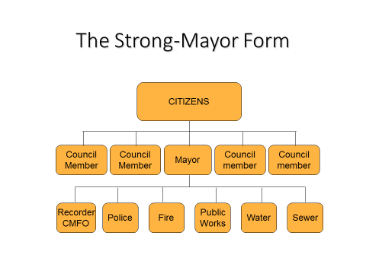

Weak Mayor

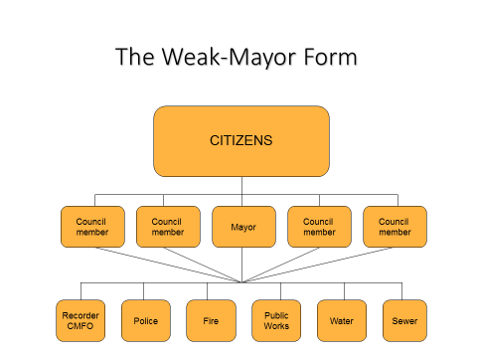

Council Manager

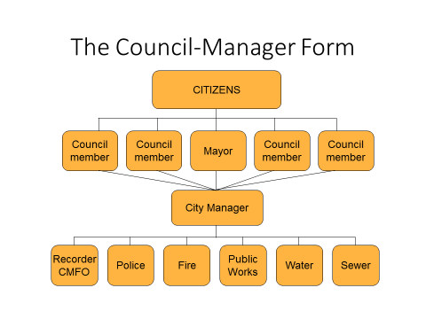

City Administrator

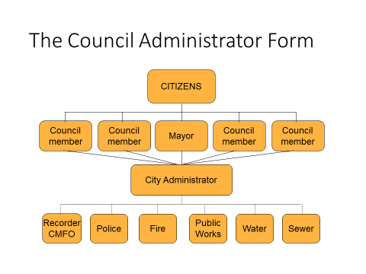

Commission Form

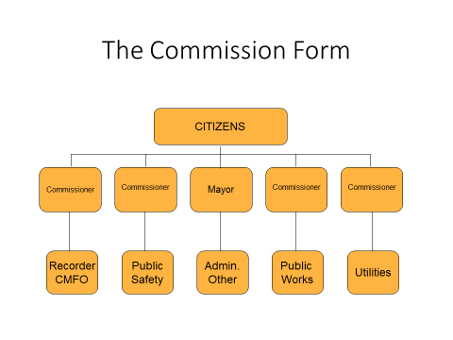

Departmental Structures

Finance and Administration Department
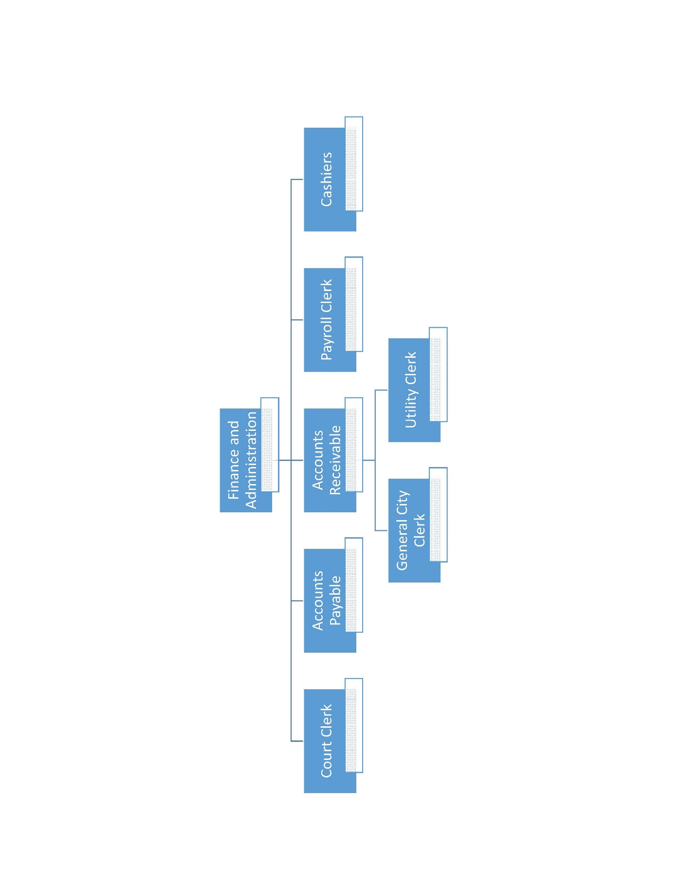

Police Department
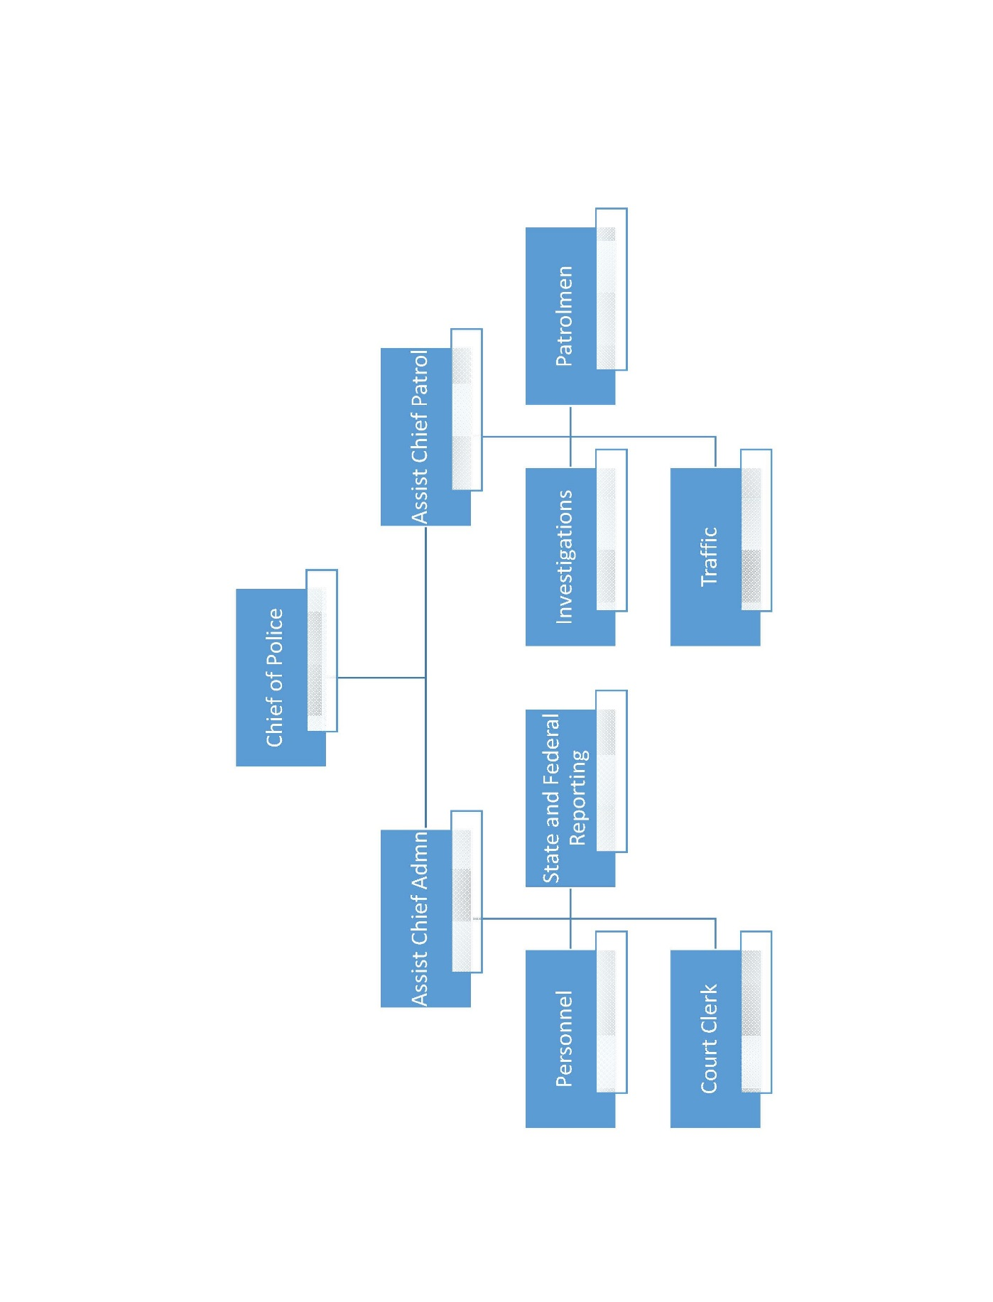

Fire Department
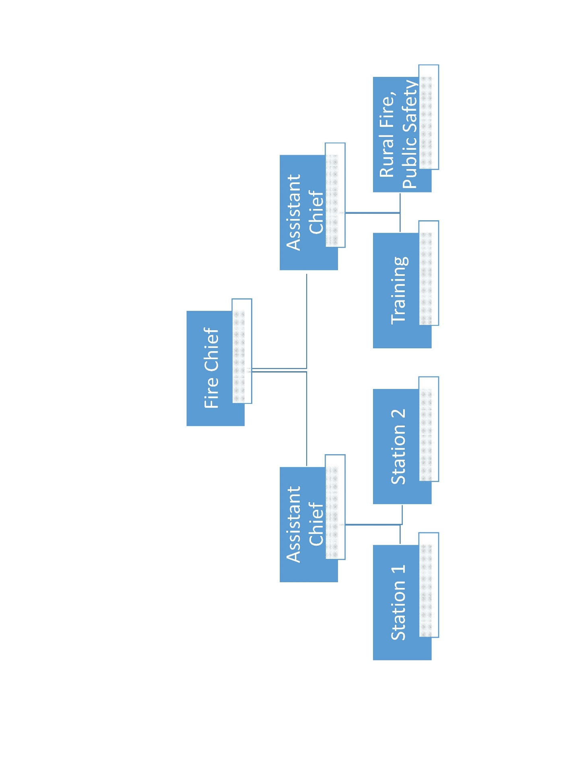

Utility Department
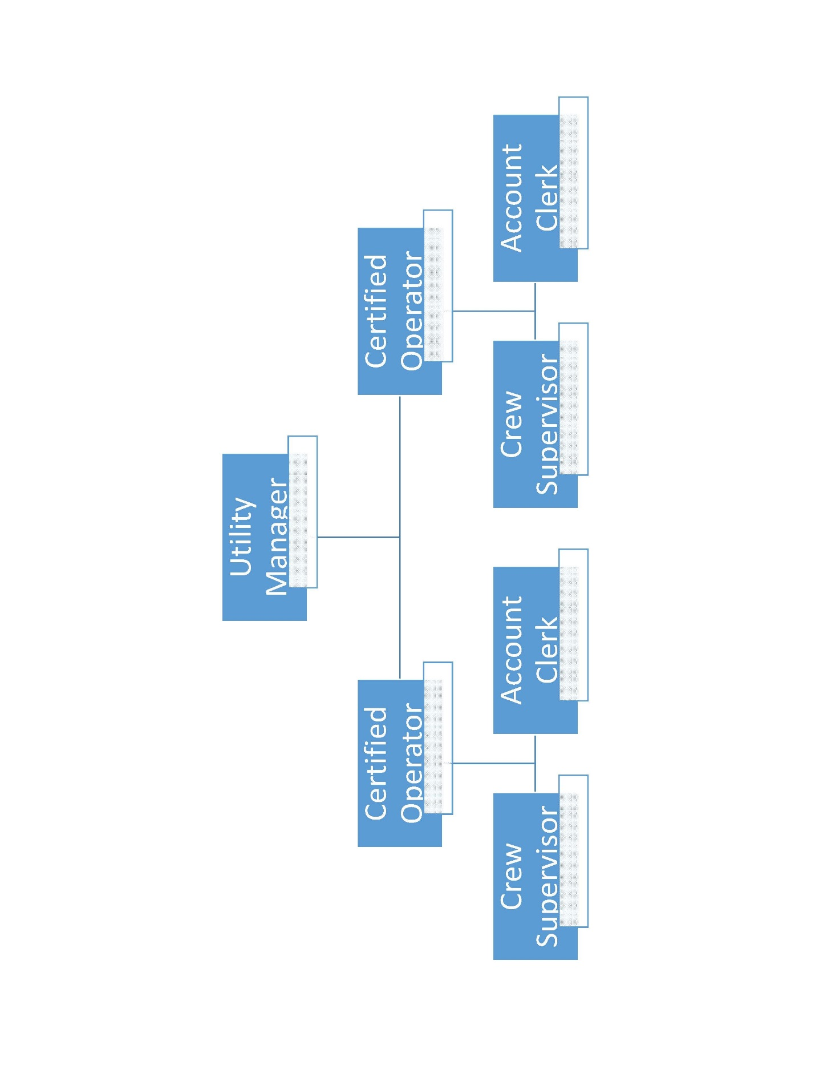

Public Works Department
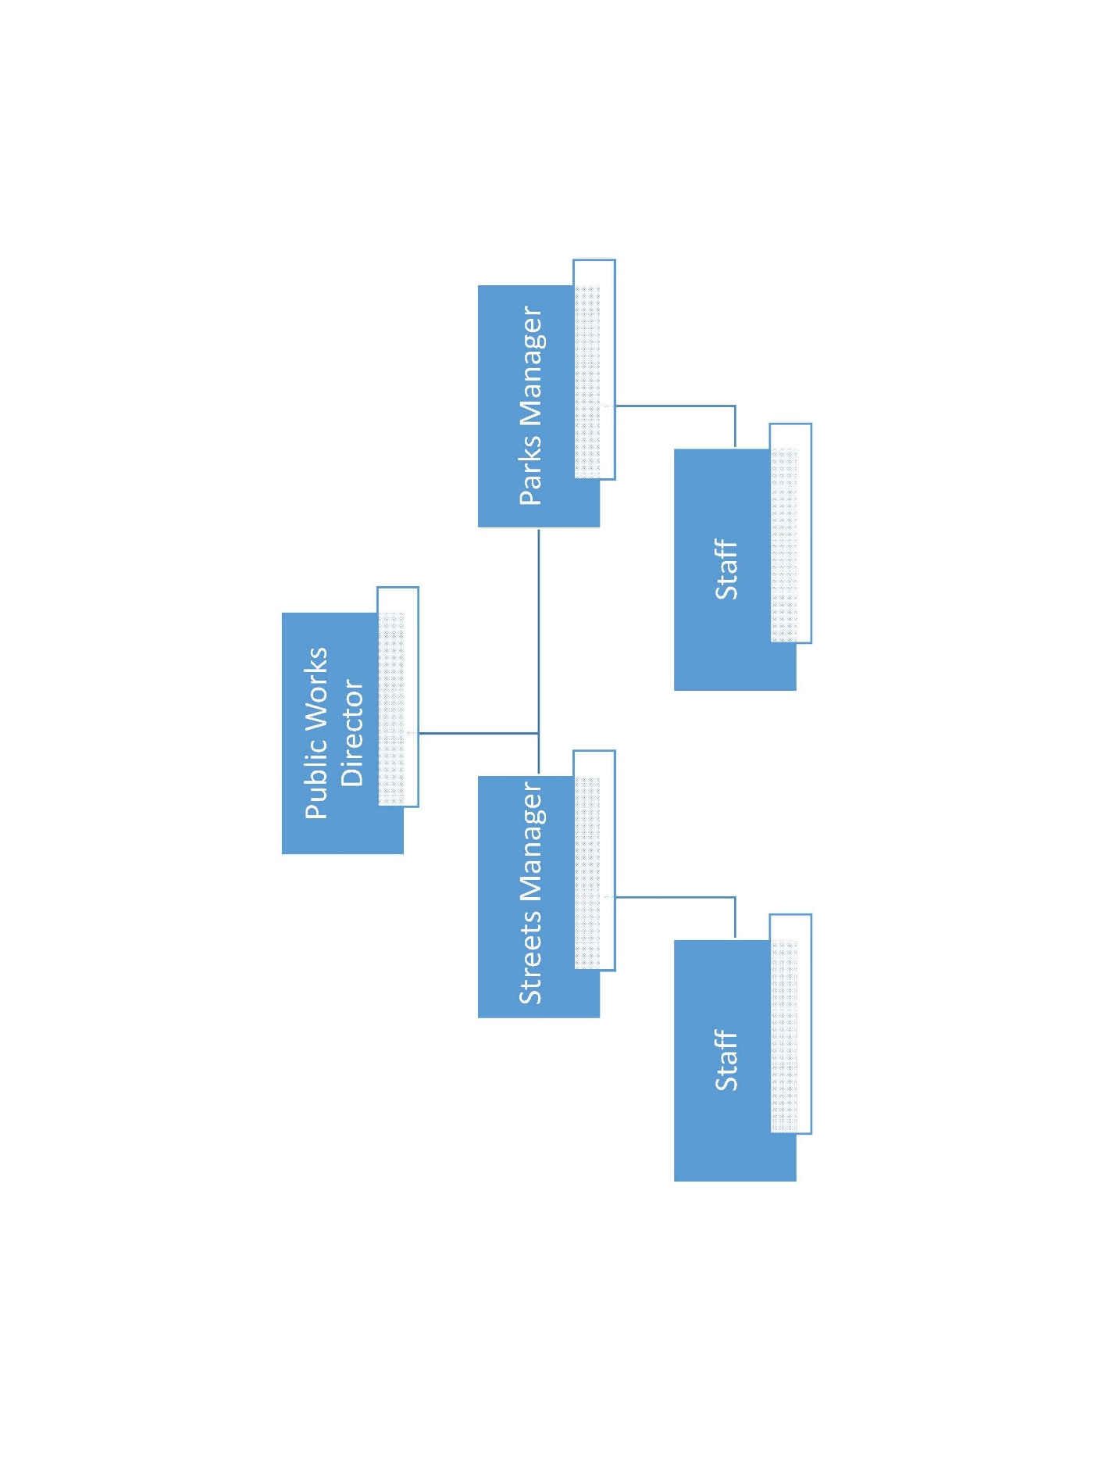

Risk Assessment
  - Overview
City officials and management assess risk of operations continually. The city has chosen to transfer the most common types of risk through the purchase of the following types of insurance:
- Property and Casualty
- Liability
- Errors and Omissions
- Worker Compensation
There are risks we cannot anticipate or know about and as it relates to financial and compliance issues we have assessed the following areas and identified certain risks that we feel need to be addressed by the development of internal control policies and procedures. Internal controls will not eliminate all risk but will help reduce risk to gain reasonable assurance that reporting and compliance objectives are being met.

Objectives

- Collections are complete, timely and accurate.
- Disbursements are for a valid city purpose and properly recorded.
- Assets are properly safeguarded.
- City is in compliance with contractual, local, state and federal laws and regulations.

Risk
Objective 1
- Collections could be lost or misappropriated.
- Collections could be recorded improperly.
- Collections may not be deposited in the bank and recorded timely.

4.2 Risk Assessment (Continued)
Risk

Objective 2
- Disbursements could be unauthorized.
- Disbursements could be for personal items.
- Disbursements could be made for items never received.

Risk
Objective 3
- Bank balances may be inaccurate due to failure to reconcile bank accounts.
- Capital assets or inventory items could be missing.
- Inventory is not available when needed.

Risk
Objective 4
- Grant funds could be spent for unallowable items.
- Grant rules may not be followed which could result in having to return federal funds.
- Federal reporting requirements were not met.

The significant areas of risk are identified above and policies and procedures will be documented in the next section to explain how the city plans to put internal controls in place to help reduce some of the risks associated with these area of operations.

Control Activities
Overview
This section is where the detailed procedures will be documented. The objectives, policies and implemented procedures will be described for each of the significant areas identified in the Risk Assessment section.

General Collections/ACHs
Objectives
- Collections are complete, timely and accurate.
- Collections are safeguarded.
- Collections should be recorded accurately and timely in the accounting system.

Policies
Objective 1
- A receipt will be issued for each collection made.
- Each cashier will have their own cash drawer.
- Two people will count down each cash drawer daily and sign the report.
- Employees are prohibited from working from another person’s cash drawer.
- No checks will be cashed from the cash drawers.
- All cash drawers will be closed out and counted daily.
- All funds will be deposited daily.
- Any monies collected at decentralized locations must be at city hall by 3:00 pm daily.
- There will be no checks or cash left out of a deposit. If there is a question as to how it should be processed, it will be deposited as miscellaneous revenue in the General Fund to be resolved later.

4.3.1 General Collections (continued)
Procedures
Procedures for policies 1-9
- The city has 3 cashiers. Cashiers 1 and 2 are general cashiers and collect everything except utility payments. Cashier 3 is the utility clerk and collects only utility payments.
- Cashiers immediately stamp all checks “for deposit only” and issue prenumbered receipts for all collections. Receipt lists date, amount, payer, proper accounting code, cash or check and is signed by cashier. A copy is given to every customer or retained with daily cash report.
- Cashier 3 will count down the cash drawers with cashiers 1 and 2. Cashiers 1 and 2 will alternate months closing and counting down Cashier 3’s drawer daily.
- Daily cash reports are given to the city clerk who makes up the bank deposits.
- A police officer is notified and takes the deposit to the bank.
- Daily cash reports and bank deposit records are given to the Finance Director.

- The Finance Director will reconcile the daily cash reports, deposit slips, and bank statements on a monthly basis. Dates will be compared to deposit records for timeliness. Receipts will be reviewed for accurate amounts, coding, proper signature and other required information.
- The Finance Director will periodically perform surprise cash counts to ensure there are no personal checks being held in the cash drawers and to ensure the drawers are in balance.
- Individual receipts issued at decentralized locations will be reconciled to the city hall receipt to determine if receipts are being turned in daily and intact. Other records will be compared such as the number of children registered for baseball on a given day, etc.

Policies
Objective 2
- All cash draws are locked when unattended.
- All cash drawers are locked in the vault during closed hours.
- Access to the vault is always restricted.
- Deposit bag is secured until the police officer arrives to transport it to the bank.
- At no time will cash be left out in the open unattended.
- Employees are prohibited from comingling city assets with personal assets.

4.3.1 General Collections (continued)
Procedures

Procedures for policies 10 - 15
- The city has 3 cashiers. Cashiers 1 and 2 are general cashiers and collect everything except utility payments. Cashier 3 is the utility clerk and collects only utility payments.
- Each cashier is issued a separate cash drawer to which they have the key. The drawers are to remain locked at all times when unattended.
- The vault should be unlocked each morning, it may be left unlocked but should remain closed during the day. Once all cash drawers are counted down they should be placed in the vault and locked for the night and the weekend. Only the Finance Director and Mayor should have access to the vault key and combination, which should be changed as there are changes in these two positions.
- All cash drawers will be closed and counted away from the front desk and will be done one at a time so there is always one cashier to take payments.
- All computer passwords will be changed periodically and access to collection, adjustment, voiding and other administrative functions will be restricted and checked regularly.

- The Finance Director will reconcile the daily cash reports, deposit slips, and bank statements on a monthly basis.
- The Finance Director will periodically perform surprise cash counts to ensure there are no personal checks being held in the cash drawers and to ensure the drawers are in balance.
- The Finance Director is the only person authorized to have computer software support change restrictions or change control levels.

Policies
Objective 3
- Chart of accounts codes will be reviewed with cashiers on a regular basis.
- All daily collection reports are posted to the general ledger by the Finance Director.
- All accounting system updates and changes are discussed with office staff and appropriate changes made if necessary.
- Reconciliations are performed monthly by the Finance Director.

4.3.1 General Collections (continued)
Procedures
Procedures for polices 16-19
- All revenue codes used by the city are kept with each cashier. The Finance Director will notify the cashiers if an account code is changed or added.
- The city clerk forwards the daily cash collection reports to the Finance Director when the deposit records are returned by the officer which alerts that the daily activity can be posted to the general ledger.
- The Finance Director will notify the office staff when computer updates are scheduled. Staff is to report any problems to the Finance Director immediately.

- The Finance Director will reconcile the daily cash reports, deposit slips, and bank statements on a monthly basis.
- The Finance Director will periodically perform surprise cash counts to ensure there are not personal checks being held in the cash drawers and to ensure the drawers are in balance.

City Courts
(The Administrative Office of the Courts rules should be used to develop these criteria)
- Objectives
- Policies
- Procedures

Property Tax Collections
- Objectives
- Policies
- Procedures

Utility Billings and Collections
- Objectives
- Policies
- Procedures

General Disbursements/Drafts

Objectives

- Disbursements are for a valid city purpose and necessary.
- Disbursements are timely.
- Disbursements are accurately coded and recorded in the accounting system.
- Disbursements are legally appropriated.

Policies
Objective 1 and 2

- The city has adopted purchasing policies that comply with state law.
- Various levels of authority have been assigned.
- Purchase orders and packing slips are matched and sent to city hall for payment as soon as possible.
- Checks are written twice each month to ensure invoices are paid timely.
- All checks require two signatures.
- All checks have documentation attached at the time of signing.

Procedures for policies 1-3
- City’s detailed procedures for polices 1-3
Procedures

4.3.2 General Disbursements/Drafts (continued)

Procedures for policies 4-6
- City’s detailed procedures for policies 4-6

Policies

Objective 3 and 4
- The finance office uses a computerized accounts payable system.
- All purchase orders are coded by purchaser and verified by the accounts payable clerk.
- Invoices are entered in the accounts payable system daily.
- The finance director reviews the accounts payable report prior to the check run.
- Budget availability is verified by the Finance Director prior to check run.

Procedures

Procedures for policies 7-10
- City’s detailed procedures for policies 7-10

4.3.2 General Disbursements/Drafts (continued)

Procedures for policy 11
- City’s detailed procedures for policy 11

Payroll disbursements and payroll liabilities
- Objectives
- Policies
- Procedures

Safeguarding of Assets
Objectives
- Ensure city assets are properly valued and protected.
- Ensure Cash, Accounts Receivable and other asset accounts are reconciled.
- Ensure investments are safe and in accordance with adopted investment policy.
- Ensure city assets are protected against loss, misappropriation or theft.
- Ensure inventory items are available when needed for use.

Policies
- All bank account statements (checking, savings, investments, etc.) are reconciled to the municipal general ledger accounts within 15 days of the date of the statement.
- Accounts receivable subsidiary ledgers are reconciled to original billings and amounts collected.
- All bank accounts are appropriately collateralized. Any bank account balance that exceeds the FDIC coverage limit will be covered at 105% of the balance as per state statute. Any bank account balance maintained in a bank participating in the State Collateral Pool will be made to verify annually the accounts held are classified on the records of the bank as “Public.”
- All bank accounts are held in financial institutions under the municipality’s name.
- All withdrawals, checks, liquidations, etc., from any bank account requires two signatures.
- All investments require two signatures.
- Inventory records contain enough information to readily identify corresponding capital assets. Capital assets are tagged or otherwise identified during a physical inventory that is performed annually.
- Proper safeguards are in place to prevent theft or loss of assets.

Procedures
Procedures for policies 1-8
- City’s detailed procedures for policies 1-8

Compliance
Objectives

- Ensure that state law regarding the issuance of debt is followed.
- Ensure that state and federal grant regulations are understood and followed.

Policies

Objective 1
- The city had adopted a debt management policy in accordance with state requirements.
- The Finance Director is well versed on the state requirements for issuing debt.

Objective 2
- Every department must notify the Finance Director when an application for 100% grant funding is submitted and subsequently awarded. All grants with matching requirements must be approved by the City Manager and Finance Director prior to submission of application.
- Once awarded, the Finance Director is to be notified of the project budget and detailed expenditure requirements of the grantor agency.
- The Finance Director must be provided with the grant contact information, grant or contract numbers and whether the grant is state or federal funds.

4.3.4 Compliance (continued)
Procedures for Policies 1-2
- City’s detailed procedures for policies 1-2
Procedures

Procedures for Policies 3-5
- City’s detailed procedures for policies 3-5

Information and Communication
  - Overview
Management has the responsibility to adequately communicate and provide information to both internal and external parties. It is important that employees know the objectives, policies and procedures management has established and what the expectations are for internal controls. External stakeholders also seek information regarding objectives and reliable financial information.
Objectives

- Necessary quality information for achieving the entity’s objectives is available and used.
- Necessary quality information for achieving the entity’s objectives is internally communicated by management.
- Necessary quality information for achieving the entity’s objectives is externally communicated by management.

4.4 Information and Communication (continued)
Policies
- Information maintained in a format should be communicated in that same format. For example, if the general ledger is maintained on computer, the monthly budget to actual reports should be provided through a computer generated report from that software package.
- Reliable and accurate quality information from municipal internal sources must be communicated to the people who need it in a timely and useful format.
- Because the credibility of the municipality, its governing body, and its public officials is at stake whenever information is released to outside parties, management should be confident the information being released is accurate and the release is in compliance with policies and procedures.

Procedures
Procedures for policy 1
- Review and document the information requirements to achieve key objectives and address the risks of the government.
- Review and document changes that occur in the local government’s objectives and the related changes in information requirements.
- Identify and evaluate the reliability and timeliness of relevant data from both internal and external sources.
- Review and evaluate whether data has been processed into quality information that allows management to make informed decisions and evaluate whether the local government is achieving its objectives

4.4 Information and Communication (continued)

Procedures for policy 2
- Management clearly defines the lines of communication through policy manuals and organizational charts.
- Management has communicated the types of information required to achieve objectives and address risks.
- All internal control documents and related reports will be available to all staff in an appropriate method based on confidentiality and relevance to job responsibilities.
- The appropriate information delivery system has been determined (e.g. email, written memo, staff meetings, etc.) for changes and updates.
- Reports containing personally identifiable information or other protected or confidential information will be made available through communication methods that restrict internal and external access.
- Annual staff training meetings and new employee orientation, with relevant handouts and manuals, will be used to reinforce memo, email, intranet, and restricted communications.

Procedures for policy 3
- Management should develop policies and procedures for communicating with external parties.
- Management should develop policies and procedures for evaluating the reliability of information provided to and received from external parties.
- Management should develop policies and procedures for ensuring that only authorized individuals provide information to external parties.
- Management should develop policies and procedures for ensuring that restricted information is provided only to authorized external parties.
- Management should develop policies and procedures for the redacting of information when requested under the open records statutes.

Monitoring
  - Overview
The internal control system changes as technology, staff, objectives and policies change. Management is charged with continually monitoring the internal control system to determine if it is operating as it was designed to do and to insure the controls are being followed.

4.5 Monitoring (Continued)
Objectives
- To practice activities to monitor the internal control system and evaluate the results.
- To address deficiencies noted in the internal control system in a timely manner.
Policies
- To ensure that internal controls do not deteriorate and continue to work as designed over time, an annual risk assessment will be conducted by municipal management.
- To establish more efficient and effective operations over time.
- To ensure accurate and reliable financial information is used in decision-making.

Procedures

Procedures for policies 1 and 2
- Evaluate and document the current state of the internal control system and document the differences between the criteria of the design and the current condition of internal control, for purposes of establishing a baseline.
- Determine whether to change the design of internal control or implement corrective actions to improve the operating effectiveness of internal control for differences that exist.
- Monitor internal control through built in monitoring activities and periodic separate evaluations and document the results.
- Evaluate differences to determine if 1) changes in internal control have occurred but have not been documented, 2) internal control has not been properly implemented, or 3) internal control design changes are needed.

Procedures for policy 3
- A member of management will review cash drawers and deposits randomly once a week to ensure policies are being followed, such as no cashing of personal checks, no borrowing from cash drawer and the makeup of cash vs checks is being documented.
- All accounts with financial institutions (checking, savings, investment, etc.) will be reconciled to the general ledger within 15 days of receipt of any statement from the financial institution.
- The above reconciliation will include a listing of outstanding checks and will be reviewed by management.
- Reconciling items on the above reconciliation will not be carried for more than 60 days.
- Reports comparing actual to budget amounts for revenues and expenditures (expenses) will be generated monthly and reviewed by those in a position of authority over financial operations. Those in a position of authority include, but are not limited to, the bookkeeper, CMFO, City Manager, Mayor, and City Council.

Summary
The framework of the manual complies with the state requirements and was created using the Green Book as guidance. Each city will need to consider each section of this manual and add other objectives, policies and procedures the city has in place or finds are necessary to add to the system. There are most likely other areas the city should perform a risk assessment on and document in the internal control manual. It is critical for the city to make this manual their own by changing it to fit your city and adding more areas that should have controls developed. Any department that would like to start on operational controls for efficiency and effectiveness can contact the MTAS specialist in your respective technical field for assistance. The specialist can usually be found listed on the MTAS website under the link of the specific topic:

