Websites:
http://wreinstate ww.tn.gov/safety/driverlicense/dllocationserv.shtml#
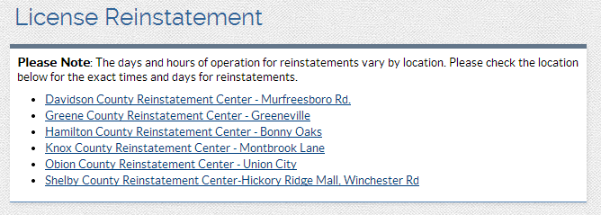

http://www.tn.gov/safety/FinancialResponsibility/frfaqs.shtml
